**CHAPTER 5 : FLOW CONTROL IN BASH**

**5.1 if/else in Bash**

The if statement in Bash is a fundamental flow control structure that allows a script to make decisions based on conditions. It determines whether to execute certain commands depending on whether a condition evaluates to true or false.

Syntax of if statement

if condition; then

Statements

elif condition; then

statements

else statements

fi

* **if condition: If the condition is true, the statements inside then will execute.**
* **elif condition: (Optional) If the first condition is false, it checks the next condition.**
* **else: (Optional) If no conditions are true, the else block runs.**
* **fi: Ends the if block.**

**EXAMPLE :**

**#!/bin/bash**

**num=10**

**if [ $num -gt 5 ]; then**

**echo "Number is greater than 5"**

**elif [ $num -eq 5 ]; then**

**echo "Number is exactly 5"**

**else**

**echo "Number is less than 5"**

**fi**

### Explanation:

* num=10 assigns the value 10 to the variable num.
* The if statement checks if num is greater than 5 using -gt.
* elif checks if it's equal to 5 using -eq.
* else handles all other cases (i.e., less than 5).
* fi ends the if block (note: it must be lowercase, not Fi).

**Common Conditions**

Conditions can check:

* Numeric comparisons (-eq, -ne, -gt, -lt, -ge, -le)
* String comparisons (==, !=)
* File properties (-f for files, -d for directories, -r, -w, -x for permissions)

EXAMPLE 2 :

#!/bin/bash

if [ -f "data.txt" ]; then

echo "File exists!"

else

echo "File does not exist!"

fi

### 

### 

### **Explanation:**

* -f "data.txt" checks if a regular file named data.txt exists in the current directory.
* If true, it prints "File exists!".
* Otherwise, it prints "File does not exist!".

**5.2 EXIT COMMAND**

1. The exit command in Bash is used to **terminate a script**.  
   Its syntax is simple:  
   exit [n]
   * n is an optional **exit status number**.
2. 🔹 The **exit status** is returned to the **parent shell or calling script**.
3. 🔹 It acts as a signal to indicate whether the script ended **successfully** or **with an error**.
4. 🔹 If you **do not provide a value** (i.e., just write exit), Bash will return the **exit status of the last command executed**.
5. 🔹 **Exit status values**:  
   * 0 → Success
   * 1 or higher → Error or custom code

### **Example:**

#!/bin/bash

echo 'Hello, World!'

exit 0

7.🔹 In the above example:

* + The script prints **"Hello, World!"** to the console.
  + Then it ends with exit 0, which signals **successful completion**.

1. 🔹 exit is useful when:  
   * If you want to **stop a script early** based on a condition.
   * You need to let another program or user know if the script **succeeded or failed**.

9.🔹 The returned exit status can be checked using:echo $?

10.🔹 exit plays a key role in **error handling**, **script chaining**, and **system-level automation**.

**#!/bin/bash**

echo 'Starting the script'

exit 0

echo 'This will not be printed'

# Output:   
# 'Starting the script'

In this script, we first print "Starting the script", and then execute the exit 0 command.  
 This command immediately terminates the script, so the line echo 'This will not be printed' is never executed.

The exit 0 command signals a successful execution of the script.  
 In Bash and other Unix-like systems, the number 0 represents success, while values from 1 to 255 are typically used to indicate different types of errors. This is part of the exit status concept in Unix systems, which we’ll explore further in the upcoming sections.

This feature of the exit command is extremely useful for error handling in scripts.  
 By checking the exit status of commands, we can make our scripts more robust, reliable, and responsive to different conditions and failures.

While exit is the standard way to terminate a Bash script, there are alternative methods such as:

* return (used inside functions)
* kill (used to terminate scripts using their Process ID or PID)  
  These alternatives may be more appropriate in specific scenarios, depending on the script’s structure and purpose.

**5.2.1 CONDITION TESTS**

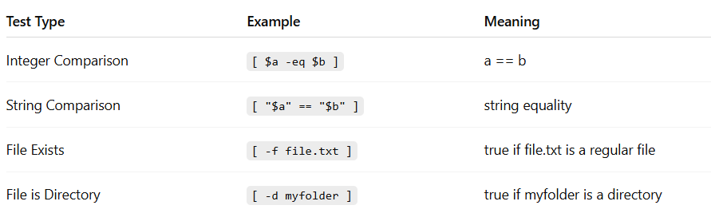

Condition tests help you make decisions in Bash scripting.  
 The main tool for testing conditions is [ ... ] or [[ ... ]], which return an exit status to indicate whether a condition is true (exit status 0) or false (non-zero).

### 🔹 1. The [ ... ] Construct

This is the traditional test syntax used in older versions of the shell.

It checks a condition and returns:

* 0 if the condition is true
* Non-zero if the condition is false

Syntax:  
 if [ condition ]; then  
   statements  
 fi

Example – Checking If a File Exists:  
 **if [ -f "data.txt" ]; then  
   echo "File exists!"  
 fi**

**Here, -f checks if "data.txt" is a regular file.  
 If it exists, the condition is true and the message is displayed.**

**Example – Comparing Numbers:  
 num=10  
 if [ $num -gt 5 ]; then  
   echo "Number is greater than 5"  
 fi**

In this case, -gt means "greater than".  
 If num is greater than 5, the exit status is 0, and the message is printed.

### 🔹 2. The [[ ... ]] Construct (Newer Version)

[[ ... ]] is an improved test syntax introduced in Bash.  
 It helps avoid common issues like word splitting and wildcard expansion.

Syntax:  
 **if [[ condition ]]; then  
   statements  
 fi**

**Example – Checking If a String Matches:  
 name="Hansika"  
 if [[ $name == "Hansika" ]]; then  
   echo "Name matches!"  
 fi**

String comparisons are safer with [[ ... ]] because:

* It avoids unexpected filename expansion from characters like * or ?
* It prevents accidental word splitting
* It supports string equality using == without extra escaping

**EXAMPLE: ELIF**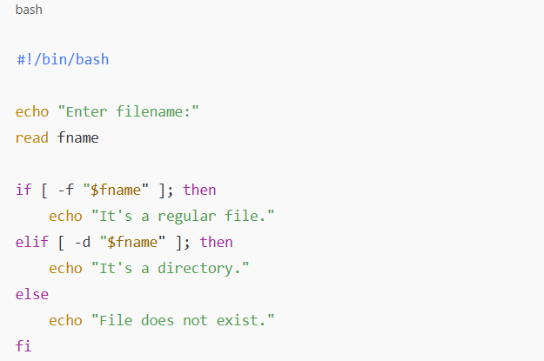

5.2.2 **Using the ‘return’ Command**

The return command is used to exit a shell function. Like the exit command, it can also provide a return status. However, unlike exit, it does not terminate the entire shell or script where it is called. Instead, it only exits the current function.

**#!/bin/bash**

function hello() {   
 echo 'Hello, World!'   
 return 0   
}

hello

echo 'This will be printed'

# Output:   
# 'Hello, World!'   
# 'This will be printed'

In this script, we define a function called hello that prints ‘Hello, World!’ and then returns with a status of 0. After calling the function, we print ‘This will be printed’.

Unlike with exit, this line is executed because return only exits the function, not the entire script.

**5.2.3 Combinations of Exit Statuses**

In Bash, every command returns an exit status after execution.

### **Exit Status in Bash:**

* 0 → Success (command ran without errors)
* Non-zero (1, 2, etc.) → Failure (an error occurred)  
  These exit statuses are especially powerful when used with logical operators to control the flow of commands.

### 🔸 **1. Logical AND (&&)**

Syntax:  
 command1 && command2

Meaning:

* Run command1
* If it succeeds (exit status 0), then run command2
* If command1 fails, command2 is skipped

Example: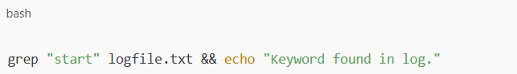

**Explanation:**

* If "start" is found in logfile.txt, the message will be printed.
* If not, the second command won't run.

### **2. Logical OR (||)**

**Syntax:** command1 || command2

**Meaning:**

* Run command1
* If it fails (non-zero exit status), then run command2
* If command1 succeeds, command2 is skipped

**🔧 Example:**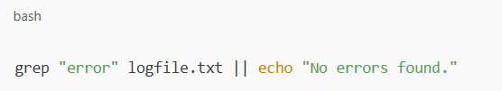

Explanation:

* If "error" is not found, the echo command runs.
* If it is found, the script proceeds without printing the message.

### **3. Logical NOT (!)**

**Syntax:** ! command

**Meaning:**

* Reverses the exit status of a command:
  + If the command fails, ! makes it a success
  + If the command succeeds, ! makes it a failure

EXAMPLE:

if ! grep "GENE" seq.txt

then

echo "GENE is NOT in the list."

fi

**Explanation:**

* If "GENE" is **not** found, the grep fails, and ! makes it pass the if condition, so the message is printed.

**5.2.4 File Attribute Checking in Bash**

In Bash, we can check if a file or directory exists, and examine its type, permissions, or ownership using file test operators inside conditional statements (if [ ... ]).

These checks are helpful in writing robust scripts that don't break when files are missing, unreadable, or unwritable.

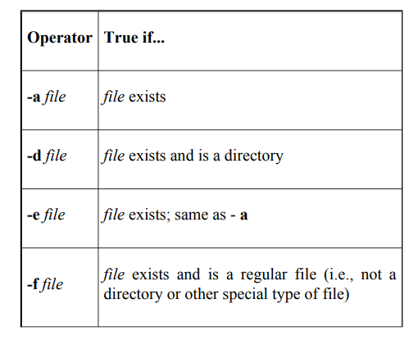

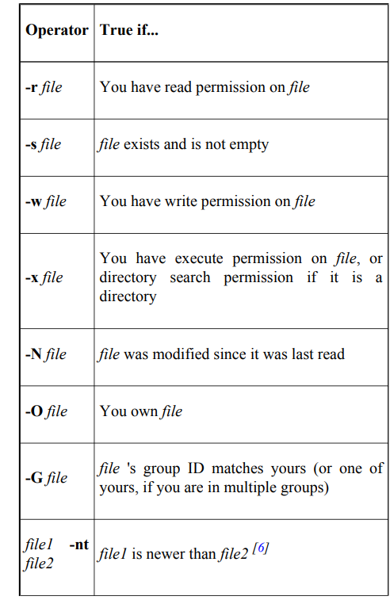

Example 1: Basic check if a file exists

**if [ -e "report.txt" ]; then  
  echo "The file exists."  
 else  
  echo "The file does not exist."  
 fi**

In this example, -e checks whether the file named "report.txt" exists in the current directory.

### 🔹 Example 2: Check if a directory is accessible

**if [ -d "$1" ] && [ -x "$1" ]; then  
  echo "$1 is a directory and you have permission to access it."  
 else  
  echo "$1 is either not a directory or not accessible."  
 fi**

This script checks if the first argument provided is a directory and whether the user has execute (search) permission.

### 🔹 Combining Expressions

* Use && to combine conditions with AND
* Use || to combine conditions with OR
* Use ! to negate a condition
* Use \( and \) to group conditions (must be escaped)

Example:  
 if [ -n "$folder" ] && [ -d "$folder" -a -x "$folder" ]; then  
  echo "The directory is valid and accessible."  
 fi

This checks if the variable folder is not empty, and whether it's a directory that the user can search.

### 🔹 Real-Life Example: File Details Checker (filecheck.sh)

**if [ ! -e "$1" ]; then  
  echo "The file $1 was not found."  
  exit 1  
 fi**

**if [ -d "$1" ]; then  
  echo -n "$1 is a directory, and you may "  
  if [ ! -x "$1" ]; then  
   echo -n "not "  
  fi  
  echo "enter it."  
 elif [ -f "$1" ]; then  
  echo "$1 is a regular file."  
 else  
  echo "$1 is a special type of file."  
 fi**

**if [ -O "$1" ]; then  
  echo "You are the owner of the file."  
 else  
  echo "You do not own the file."  
 fi**

**if [ -r "$1" ]; then  
  echo "You can read this file."  
 fi**

**if [ -w "$1" ]; then  
  echo "You can write to this file."  
 fi**

**if [ -x "$1" ] && [ ! -d "$1" ]; then  
  echo "You can execute this file."  
 Fi**

**5.2.5 Integer Conditionals in Bash**

The shell also provides a set of arithmetic tests. These are different from character string comparisons like < and >, which compare lexicographic values of strings,[8] not numeric values. For example, "6" is greater than "57" lexicographically, just as "p" is greater than "ox," but of course the opposite is true when they're compared as integers. 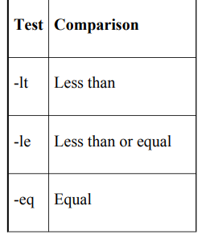

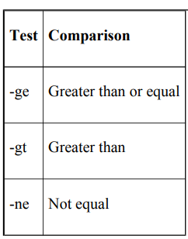

### 

### **1. String vs Integer comparsion**

In Bash, comparisons can be either **string-based** or **integer-based**.

* **String comparisons** (using <, >) compare values based on **lexicographic (dictionary) order**.
* **Integer comparisons** compare values **numerically**.

**Example – String (Lexicographic) Comparison:**

if [ "6" > "57" ]; then  
  echo "6 is greater than 57 (string)"  
 else  
  echo "6 is not greater (string)"  
 fi

**Output:** 6 is greater than 57 (string)  
 *Explanation:* Lexicographically, "6" comes after "5", so it's considered greater.

**Example – Integer Comparison:**

if [ 6 -gt 57 ]; then  
  echo "6 is greater (integer)"  
 else  
  echo "6 is not greater (integer)"  
 fi

**Output:** 6 is not greater (integer)  
 *Explanation:* Numerically, 6 is less than 57.

### 

### 

### **3. Important Notes**

* The < and > operators used for **string comparisons** must be **escaped** using a backslash (e.g., \<, \>) when using [ ... ] to avoid shell misinterpretation.

 Example: [ "$a" < "$b" ]

* The test command is **equivalent** to [ ... ] in functionality.

 Example: test "$a" -eq "$b" is the same as [ "$a" -eq "$b" ]

EXAMPLE:

**Compare two numbers:**

a=10  
 b=20

if [ $a -lt $b ]; then  
  echo "$a is less than $b"  
 fi

**Efficient version using double parentheses:**

if (( a < b )); then  
  echo "$a is less than $b (efficient check)"  
 Fi

**5.3 FOR LOOP IN BASH**

In Bash scripting, the for loop is one of the most powerful and frequently used constructs.

It allows you to repeat a block of code multiple times, making automation, iteration over lists, arrays, and numeric ranges easy and efficient.

### **1. Simple for Loop (Fixed List)**

This loop iterates over a fixed list of values such as letters, words, or numbers.

Example:  
 for n in a b c  
 do  
  echo $n  
 done

**Explanation:**

* The loop will run 3 times.
* Each time, the variable n takes a new value from the list: a, then b, then c.
* The echo statement prints the value of n in each iteration.

### **🔹 2. Range-Based for Loop**

You can use **curly braces {}** to loop over a range of numbers.

Example:  
 for i in {1..5}  
 do  
  echo $i  
 done

**Explanation:**

* This loop runs from 1 to 5.
* The loop automatically increments by 1 in each cycle.

To change the step size, you can use:  
 for i in {1..10..2} (from 1 to 10, step 2)

### **🔹 3. Array Iteration with for Loop**

You can loop through an array using the [@] symbol to access all elements.

Example:  
 sports=("football" "cricket" "hockey")  
 for game in "${sports[@]}"  
 do  
  echo $game  
 done

**Explanation:**

* The loop goes through each item in the sports array.
* Each element (e.g., football, cricket, hockey) is assigned to the variable game during its turn.

### **🔹 4. C-Style for Loop**

Bash also supports a C-like syntax, useful when you need **numeric control** like initialization, condition checking, and incrementing in one line.

Example:  
 n=7  
 for (( i=1; i<=n; i++ ))  
 do  
  echo $i  
 done

**Explanation:**

* i starts at 1.
* The loop continues as long as i is less than or equal to n.
* i increases by 1 in each cycle.
* Prints numbers from 1 to 7.

This style is efficient for numeric operations and gives you more control than fixed lists.

**5.3.1 CASE Statement in Bash**

The case statement in Bash is used for multi-way decision-making.  
 It allows you to compare a variable or expression against multiple possible values or patterns and execute different blocks of code based on the match.

This construct is cleaner and easier to manage than writing multiple if-else statements.

### 🔹 **Key Features of Case Statements**

* Works like switch-case in other languages (like C or Java), but simpler.
* No need for a break statement — Bash automatically stops after the first match.
* Supports multiple patterns using the pipe symbol |.
* Includes a default case using *, which runs if no pattern matches.
* Ends with the keyword esac (which is case spelled backward).

### 🔹 **Syntax of a Case Statement**

case EXPRESSION in  
  pattern1)  
   statements  
   ;;  
  pattern2)  
   statements  
   ;;  
  ...  
  *)  
   default statements  
   ;;  
 esac

### 🔹 **How It Works**

1. The EXPRESSION is evaluated once.
2. The result is compared against each pattern.
3. When a match is found, the corresponding block of code runs.
4. After the match, Bash exits the case block — no further checking.
5. If no patterns match, the default block marked by * is executed.

### 🔹 **Example 1: Department Description**

DEPARTMENT="Computer Science"  
 case $DEPARTMENT in  
  "Computer Science")  
   echo "Computer Science"  
   ;;  
  "Electrical Engineering" | "EEE")  
   echo "Electrical Engineering"  
   ;;  
  "Information Technology" | "Electronics and Communication")  
   echo "IT or E&C"  
   ;;  
  *)  
   echo "Invalid Department"  
   ;;  
 esac

Explanation:

* Matches the variable DEPARTMENT with multiple possible department names.
* If it matches "Computer Science", it prints that.
* If none match, it prints "Invalid Department".

### 🔹 **Example 2: Case Inside a For Loop**

DEPARTMENTS=("IT" "EEE" "Mechanical")  
 for dept in "${DEPARTMENTS[@]}"  
 do  
  case $dept in  
   "IT") echo "Information Technology" ;;  
   "EEE") echo "Electrical Engineering" ;;  
   *) echo "Other Department" ;;  
  esac  
 done

Explanation:

* Iterates over an array.
* Matches each item to print the corresponding department.

### **🔹 Example 3: User Input for Yes/No**

echo "Are you a student? [yes or no]"  
 read response  
 case $response in  
  "yes" | "Yes" | "Y" | "y")  
   echo "Yes, I am a student."  
   ;;  
  "no" | "No" | "N" | "n")  
   echo "No, I am not a student."  
   ;;  
  *)  
   echo "Invalid input."  
   ;;  
 esac

Explanation:

* Takes user input and matches different variations of "yes" or "no".
* Responds accordingly.
* Default case handles incorrect input.

### 🔹 **Example 4: Process Signal Handler**

If the script receives a signal number and a PID (Process ID), it can send specific system signals.

Example:

case "$1" in  
  1) send SIGHUP to $2 ;;  
  2) send SIGINT to $2 ;;  
  3) send SIGQUIT to $2 ;;  
  *) echo "Unknown signal" ;;  
 esac

Explanation:

* Based on the signal number (first argument), the script sends a corresponding signal to the process with the given PID (second argument).
* Helps in managing running processes.

### **Advantages of Using Case Statements**

* Cleaner than multiple if-elif-else chains.
* Easier to read and maintain.
* Supports pattern matching using wildcards.  
  Ideal for handling user inputs, menu options, or grouped choices.

**5.4 select Statement in Bash**

The select command in Bash is used to create simple menus in scripts.  
 It allows users to choose from a list of options, making the script more interactive and user-friendly.

### **🔹 Key Features of select**

* Displays a numbered list of options.
* Waits for the user to enter a number corresponding to their choice.
* Stores the selected value in a variable.
* Commonly used with case statements for processing the selection.
* Automatically provides a prompt for selection.
* Runs in a loop by default (use break to exit).

### **🔹 Syntax**

select variable in list  
 do  
  statements  
 done

### **🔹 How It Works**

1. The select command displays each item in the list with a number.
2. The user types the number of their choice.
3. The selected value is stored in the specified variable.
4. The loop body executes based on the selection.
5. Typically combined with a case block to handle choices.
6. The loop continues until you manually break it.

### **🔹 Example: Simple Menu**

options=("Play" "Pause" "Stop" "Exit")  
 select choice in "${options[@]}"  
 do  
  case $choice in  
   "Play") echo "Playing music" ;;  
   "Pause") echo "Music paused" ;;  
   "Stop") echo "Music stopped" ;;  
   "Exit") echo "Exiting menu"; break ;;  
   *) echo "Invalid choice" ;;  
  esac  
 done

**Explanation:**

* Displays a menu with Play, Pause, Stop, and Exit.
* User inputs the number corresponding to a choice.
* The script responds accordingly.
* Exits when "Exit" is selected.

### **✅ Advantages of select**

* Great for creating simple interactive menus.
* No need to manually number or format options.
* Easy to integrate with case for clean control flow.
* Useful for scripts where user interaction is required.

**EXAMPLE DNA SEQUENCE:**

**#!/bin/bash**

**# Define the DNA sequence**

**DNA="ATGCTAGCTAGGCTA"**

**# Set custom prompt for select menu**

**PS3="Choose an operation on the DNA sequence: "**

**# Display menu options**

**select operation in "Show sequence" "Length of sequence" "Count nucleotides" "Complement" "Quit"**

**do**

**case $operation in**

**"Show sequence")**

**echo "DNA sequence: $DNA"**

**;;**

**"Length of sequence")**

**echo "Length of the sequence: ${#DNA}"**

**;;**

**"Count nucleotides")**

**echo "Nucleotide counts:"**

**echo "A: $(echo "$DNA" | grep -o "A" | wc -l)"**

**echo "T: $(echo "$DNA" | grep -o "T" | wc -l)"**

**echo "G: $(echo "$DNA" | grep -o "G" | wc -l)"**

**echo "C: $(echo "$DNA" | grep -o "C" | wc -l)"**

**;;**

**"Complement")**

**complement=$(echo "$DNA" | tr 'ATGC' 'TACG')**

**echo "Complement: $complement"**

**;;**

**"Quit")**

**echo "Exiting the program..."**

**break**

**;;**

**\*)**

**echo "Invalid choice. Please select a valid option."**

**;;**

**esac**

**done**

**5.5 while and until Loops in Bash**

### 🔹 1. while Loop

The while loop runs as long as the condition is true.  
 It checks the condition before each iteration. If the condition becomes false, the loop stops.

Syntax:

while [ condition ]; do  
  commands  
 done

How it works:

* If the condition is true, the loop body executes.
* After each run, the condition is re-checked.
* When the condition becomes false, the loop ends

Example:

count=1  
 while [ $count -le 5 ]; do  
  echo $count  
  count=$((count + 1))  
 done

This loop prints numbers from 1 to 5.

### 🔹 2. until Loop

The until loop is the opposite of the while loop.  
 It runs the loop until the condition becomes true.

Syntax:

until [ condition ]; do  
  commands  
 done

How it works:

* If the condition is false, the loop body runs.
* After each iteration, it checks again.
* Once the condition becomes true, the loop ends.

Example:

count=1  
 until [ $count -gt 5 ]; do  
  echo $count  
  count=$((count + 1))  
 done

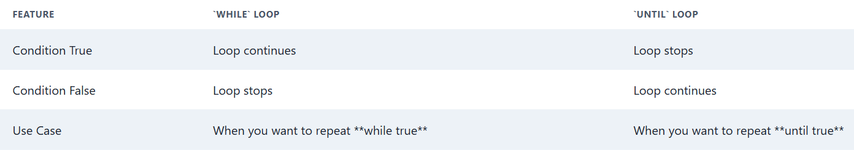

### **Infinite Loop Example Using while**

while true; do  
  echo "Press CTRL+C to stop."  
  sleep 1  
 done

This loop runs forever unless manually stopped.

1.Example Using while Loop

Read a FASTA file line by line and count sequences

#!/bin/bash

count=0

while read line; do

if [[ $line == ">"* ]]; then

count=$((count + 1))

fi

done < sequences.fasta

echo "Number of sequences in the file: $count"

2.Example Using until loop

#!/bin/bash

DNA="ATGCGTACTGAAGCTAGTGA"

codon=""

index=0

until [[ $codon == "TAG" || $codon == "TAA" || $codon == "TGA" ]]; do

codon=${DNA:$index:3}

echo "Reading codon: $codon"

index=$((index + 3))

done

echo "Stop codon encountered: $codon"

### **Explanation:**

* The until loop keeps reading the DNA string 3 bases (1 codon) at a time.
* It continues **until** it finds a stop codon.
* The loop then ends and reports the stop codon found.

***SUMMARY***

